

**MIDDLE EAST TECHNICAL UNIVERSITY**

**DEPARTMENT OF ELECTRICAL & ELECTRONICS ENGINEERING**

**EE 463 - Static Power Conversion I - Term Project**

**Deadly Viper Assassination Squad Inc.**

**Development of a AC-DC Battery Charger for Rooftop Wind Turbine Applications**

**Mehmet KILIÇ - 2232262**

**Ali BELLİ - 2231421**

**Mustafa YILDIZ - 2233013**

Table of Contents

**Type chapter title (level 1)1**

Type chapter title (level 2)2

Type chapter title (level 3)3

**Type chapter title (level 1)4**

Type chapter title (level 2)5

Type chapter title (level 3)6

1. **Introduction**

Deadly Viper Assassination Squad Incorporation (D.V.A.S. Inc.) is established to provide practical solutions to the problems in the power electronics area. The main application areas in the power electronics field are AC to DC rectifiers and DC to DC converters.

In recent years, effects of climate change have started to show themselves at various locations of the world. Although we are at the beginning of the expected huge climate shift, we are already experiencing unusual meteorological events. In order to delay the effects of climate change, governments and companies have started to invest on renewable energy sources. Therefore, the share of renewables in the energy production industry is getting larger every year.

In addition to the conventional bulk power plants, distributed energy resources (DER), which is a new concept that appeared with the advancements in the renewables area, are being used in order to decrease the carbon emissions of the end user. Instead of large power plants in MW scale, the number of small power generation units located in the distribution level is increasing.

In this project, D.V.A.S. inc. proposes a solution for the interface between a small wind turbine located at the top of the EEE department of the METU and it’s battery. First stage of the proposed solution includes AC to DC conversion of the wind turbine output whose frequency and amplitude varies randomly. Then, rectified variable-DC voltage is regulated to provide charging operation for the battery.

Project is completed in two steps. Preceding report was including the conceptual design discussion, simulation results and CAD model of the proposed solution. After submitting this report and getting feedback, development process is continued according to the feedback taken. This report represents the final version of the developed system including design, simulation, component selection, cost analysis, thermal analysis and PCB design parts.

1. **Problem Definition**

The main problem that yields us to work on this project is that the road next to the park of the EEE department needs to be illuminated continuously even in the nights. This action requires a large energy supply which is not available in that condition. For this reason, a small wind turbine is placed at the top of the roof. However, the speed and strength of the wind is not constant. Therefore, converted electrical energy must be stored in order to use at the evening hours for illumination. For storage, a battery is used at the output of the wind turbine. Proposed AC-DC charger design will convert variable AC to constant DC. Since the terminal voltage of the electrochemical battery would change with its state of charge, the charger must supply constant current DC independent of the terminal voltage of the battery. This definition intuitively shapes our design.

The system specifications for this project are defined as below.

* Open circuit voltage peak: 330
* Battery capacity: 13 Ah
* Battery nominal voltage: 24 V
* Output current: 2 A
* Output current ripple: %20 of average current.
* Inertia: 0.00027 kg.m^2
* Viscous Damping: 0.005024 N.m.s
* Poles: 2
* Voltage Constant: 110
* Stator Resistance: 10.58 Ohm
* Armature Inductance: 16.7 mH

1. **Topology Selection**

In preceding chapter, problem definition is made, and the conceptual requirements are determined without entering the technical design discussion. In this step, possible topologies which satisfy the requirements defined above will be discussed and selected topology will be represented. According to the problem definition, we have determined that below topologies are suitable for this application.

* Three Phase Full Bridge Thyristor Rectifier
* Three Phase Full Bridge Diode Rectifier + Buck Converter (x2)
* Three Phase Full Bridge Diode Rectifier + Buck Converter

Using a three-phase full bridge Thyristor rectifier would be beneficial in order to decrease the size and number of the components. However, in this case 6 gates must be controlled at the same time. This would increase the cost because we need to feed 6 gate signals at the same time which requires 3 phase control drivers. Also, controlling 6 gates at the same time would increase the complexity of the controller and decrease the reliability of the system. For that reasons, a Thyristor rectifier is not preferred.

After eliminating the Thyristor rectifier, the team focused on the diode rectifier + buck converter topology. The given source in the project is a three-phase generator which means that we need to select a three-phase rectifier type. At this stage, three phase half wave/full wave diode rectifier topologies are considered. According to the output current specification, we need to feed the system with a high voltage so that we can reach 2A at the buck converter output. Therefore, a three-phase full bridge diode rectifier is determined as the best option for this application thanks to its larger voltage output.

Since the output voltage of the rectifier is large, whether a single buck converter would be capable of converting it for the battery or not is discussed. Note that the controller must operate at higher frequencies in order to convert such a high voltage to the 24V 2A DC. After conducting a short market research, it is found that there are plenty of analog controller ICs that can operate in such conditions. Therefore, a single stage buck converter is preferred in order to decrease the cost, number of components and volume of the design.

After determining the number of buck converter stages, control strategy is discussed. Batteries can be charged in constant voltage, constant current or constant current-constant voltage modes of operation. Since the terminal voltage of the battery varies depending on its state of charge, the constant current charging method is adopted due to its simplicity. In the design, output current will be kept constant by an analog controller IC. Details of the controller will be discussed in detail later.

A typical buck converter topology circuit diagram is given below.

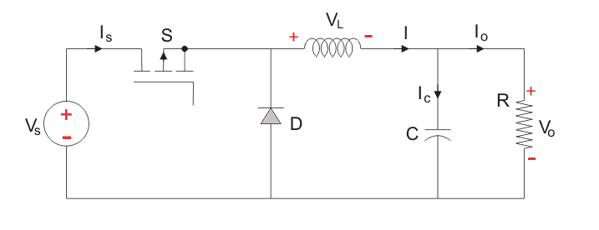

Figure 1: Buck Converter topology

In order to increase the efficiency by decreasing the diode losses, diode D is changed with a MOSFET, and this configuration is known as synchronous buck converter. The synchronous buck converter circuit diagram is shown below.

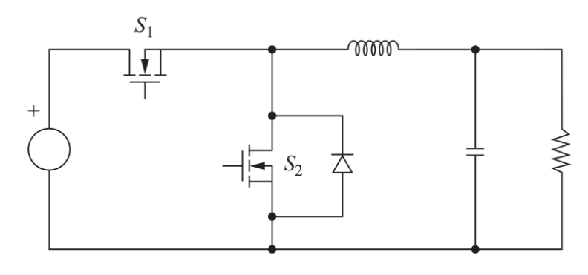

Figure 2: Synchronous buck converter topology

1. **Design**

In this part, values of capacitors and inductor are determined. Also, controller block is designed for simulations. Note there are two capacitors, one at the rectifier output and other one at the converter output. Also, value of inductance must be determined for buck converter.

First, capacitance at the rectifier output is determined. This capacitor decreases the output voltage ripple significantly. Since there is no specification about the rectifier output ripple, complete elimination of the ripple voltage was not the aim. Instead, an easy to find capacitor is selected and the result was satisfying (Given in simulation part). Therefore, a 470-microfarad capacitor is selected for rectifier. However, in order to decrease the size of the circuit, two series 270-microfarad capacitors are used. Their equivalent capacitance is 540-microfarad. Size is decreased and larger capacitance provides better ripple filtering.

Then, the inductor and capacitor values are determined for buck converter. Equations below are used for the calculations. Note that, equations include voltage and current ripple values. Therefore, allowable ripple values are also used and resulting capacitor and inductor satisfy this ripple values.

After inserting circuit parameters to the equation (1), can be found as below.

After inserting circuit parameters to the equation (2), can be found as below.

These values are the minimum ones. For the sake of the reliability, the parameters were chosen larger than these minimum values which are presented in the above. For the buck converter, 1.5 microfarad capacitor and 1 milihenry inductor are used in order to obtain the required results. It can be also observed that for the chosen inductance value, system will work in the continuous conduction mode. The proof of this can be followed in the below derivations.

From here, inductance can be leave alone as below.

can be calculated from the load characteristics, where there exists 24V nominal voltage with average 2A current. From here can be calculated as.

At the output of the rectifier, there exists an average of 250 V at the steady state. This output is sent to the input of the buck converter and converted to 24V. From here duty cycle can be extracted as below.

Obtained variables in equations, in equation 3.3 and 3.4, can be inserted to the equation 3.2. The result is as below.

As can be seen from the equation, the found inductance value for the CCM operation is the minimum value. Therefore, the one chosen in the above, 1mH inductance value, is guaranteed to work the Buck Converter on the CCM mode.

Then, the controller is designed with two outputs. At first, designed controller was taking output current as a measurement and comparing it with reference current. Then passing it through a P controller. Amplified P controller output was being compared with a constant frequency sawtooth waveform. If the difference between the amplified error and sawtooth is less or equal than zero, M1 was on and M2 was off. The system was working based on this process. Although this controller was be able to provide constant 2 A output current, inductor current ripple was weird, and reason could not be found. Then, according to the feedback taken in feedback session, a hysteresis (on-off) controller is designed. Such a controller operates as follows; a hysteresis band is determined and error between measured and reference currents is compared with the hysteresis bounds. If error exceeds upper limit, switch is off and vice versa. Figure 3 shows the old controller used in simulation report. Figure 4 shows the new controller.

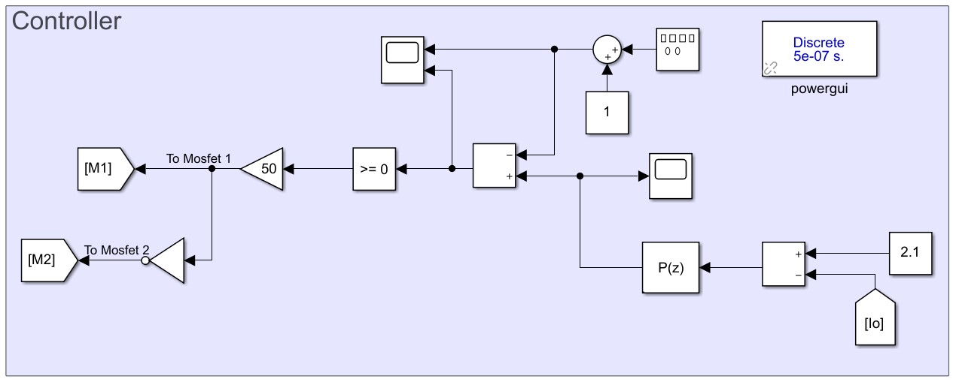

Figure 3: Controller block (old)

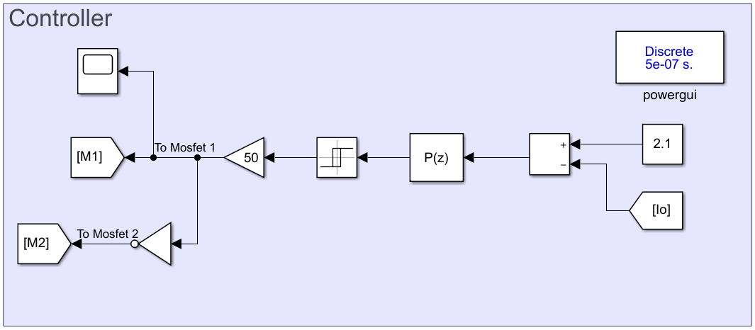

Figure 4: Hysteresis controller block (new)

Finally, overall system design is completed, and complete simulation model is constructed. In simulations part, results are represented. Figure 5 shows the overall system simulation results.

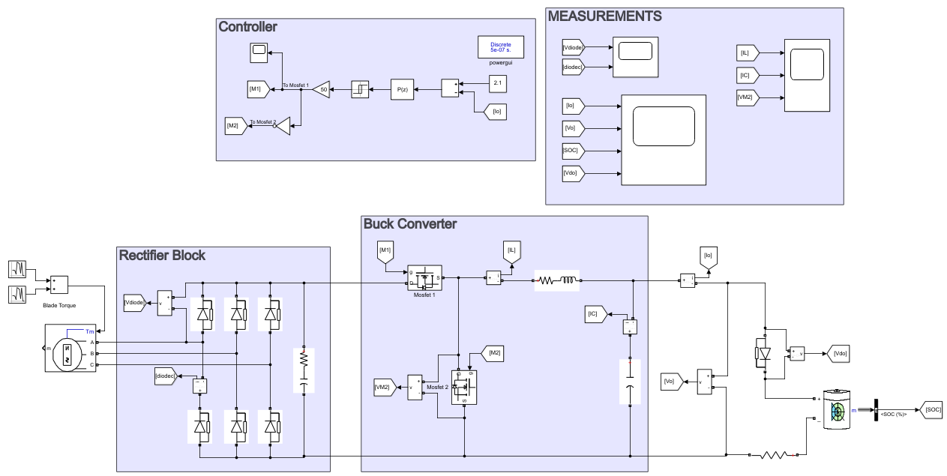

Figure 5: Overall system simulation model

1. **Simulation Results**

In this part of the report simulation results are represented. During the simulations, voltage drop and current of each component are measured. According to these measurements, ratings of the components are determined, and components are selected accordingly. Then, non-idealities of these components are included, and simulations are repeated. Results given in this report represent the non-ideal (final) case.

First, diode rectifier simulations are presented. The rectifier topology configuration is as shown in figure 5.

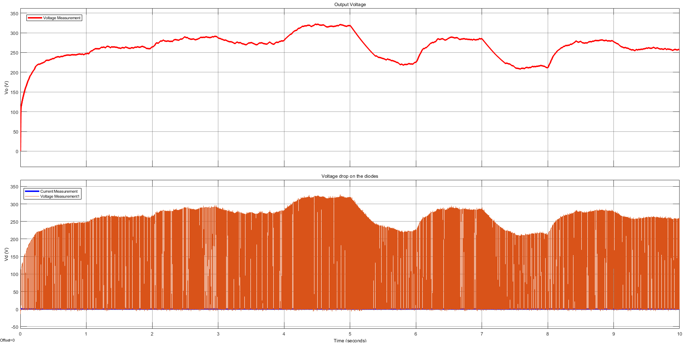

.

Figure 7:Rectifier output voltage waveform 470 microfarad capacitor inserted.

Figure 6 shows the output voltage and voltage drop on the diodes. Increasing the capacitor value could decrease the ripple value. However, since the controller of the buck converter would adjust the output voltage automatically, dimensions of the capacitor become the most important parameter. Since the selected capacitor provides enough filtering with relatively small volume, there is no need for larger capacitors.

Then, buck converter is simulated. Figure 7 shows the simulation model.

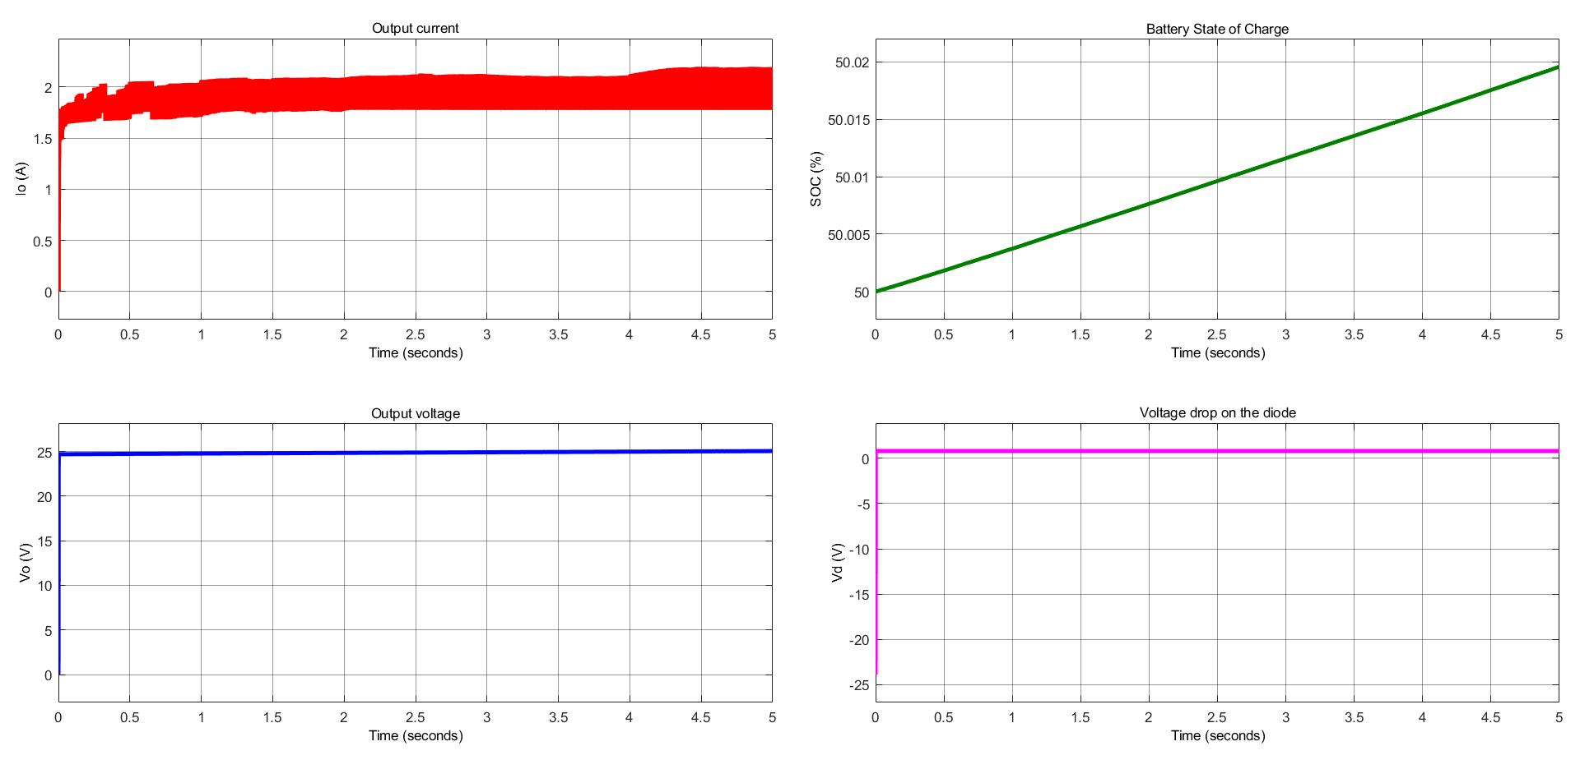

Figure 9: Simulation results for buck converter

As can be seen from the above figure, the output current waveform is within the %20 percent ripple current in the 2A specification. Output voltage is constant at 24V because the state of charge is almost constant. Note that supplying 2A for 10 seconds cannot charge the battery significantly. In addition to the buck converter, a series diode is added at the output because at the beginning the smoothing capacitor of the buck converter is empty. If that battery is charged, it would discharge on the capacitor. In order to avoid this reverse current flow, a series diode is added at the output. Figure 7 also verifies that this measure is meaningful because the voltage on the diode at t=0 is negative, which means that if the capacitor would not be used, the battery would discharge into the capacitor.

1. **Component Selection**

In this part of the report, the component selections are presented. The followed roadmap for the component selection is measuring the related voltages and currents for the analyzed component. According to the stresses over them the related components are selected. In this report the selections starting from the rectifier stage to the end stage are presented orderly.

* 1. **Rectifier Stage**

In the rectifier stage there are two components: diodes and capacitor. The voltage and current measurements for the rectifier diodes were given in figure 7 as below.

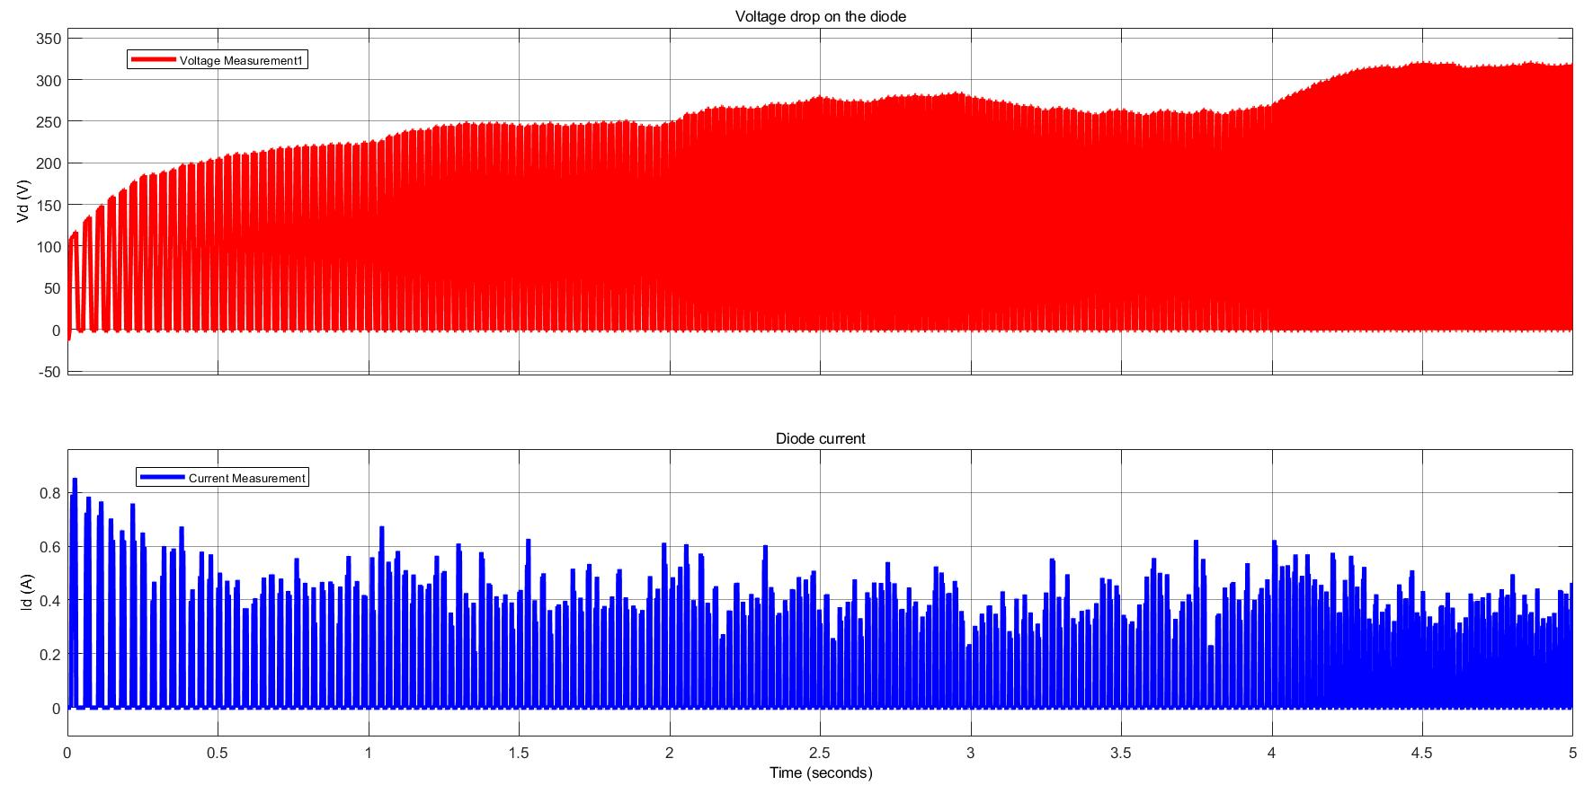

Figure 7.Rectifier diode characteristics

For the safety of the design, components need to be selected with 1.5 multiples of the measurements. The voltage over diodes will be measured as approximately 325V, and the currents as maximum 0.9A. Then according to the extreme points selected diode is presented in table X.

Table 1. Rectifier stage power diode parameters

|  |  |
| --- | --- |
| **Component Code** | **AS4PJ** |
|  | 4.0 A |
|  | 600 V |
|  | 175 ℃ |
|  | 0.92 V |
|  | SMPC (TO-277A) |

The table 1 shows important parameters for the diode. The maximum repetitive reverse voltage that this diode can carry is 600V and forward current is 4A. These ratings are at least 1.5 multiples of the actual stresses shown in figure 7.

The next component is the capacitor. It will be selected according to the voltage over it. It sees output voltage, and rectifier output voltage characteristics are shown in figure 10.

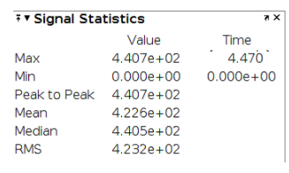

Figure 9. Rectifier output voltage characteristics

The capacitor is faced with at most 441V peak. Therefore, the capacitor needs to be selected accordingly its rated voltage which should be larger than 441V. Since these types of circuit components are dangerous for the health of the circuit board, these selections should be made at least 1.5 multiples of the capacitor maximum voltage level in order to prevent it from exploding. However, selecting one capacitor that is capable of carrying almost 500-600V increases the product size effectively. It is not desired for this project design point of view. It is desired to design a product that is cheapest and smallest.

For that purpose, capacitor can be divided into smaller size capacitors, and can be connected in parallel. By selecting the size and the number of capacitor in the optimum point, the requirements for this stage can be met. According to these explanations, 2 identical aluminum capacitors are selected, and their properties are given in table 2.

Table 2. Rectifier Capacitor Rated Values

|  |  |
| --- | --- |
| **Component Code** | **Rubycon MXH Series** |
| Rated Voltage Range | 400-550 |
| Selected Capacitor Rated Voltage | 450 |
| Size | 270 µF |
| Operating Temperature Range | -25℃ - 105℃ |
| Size of Capacitor | 30x30 mm |

With the above discussions, rectifier side components selection is completed.

* 1. **Converter Stage**

For the converter side switching element (MOSFET), inductor and capacitor should be selected. The following figure 11 shows the inductor current, capacitor current and Mosfet ratings.

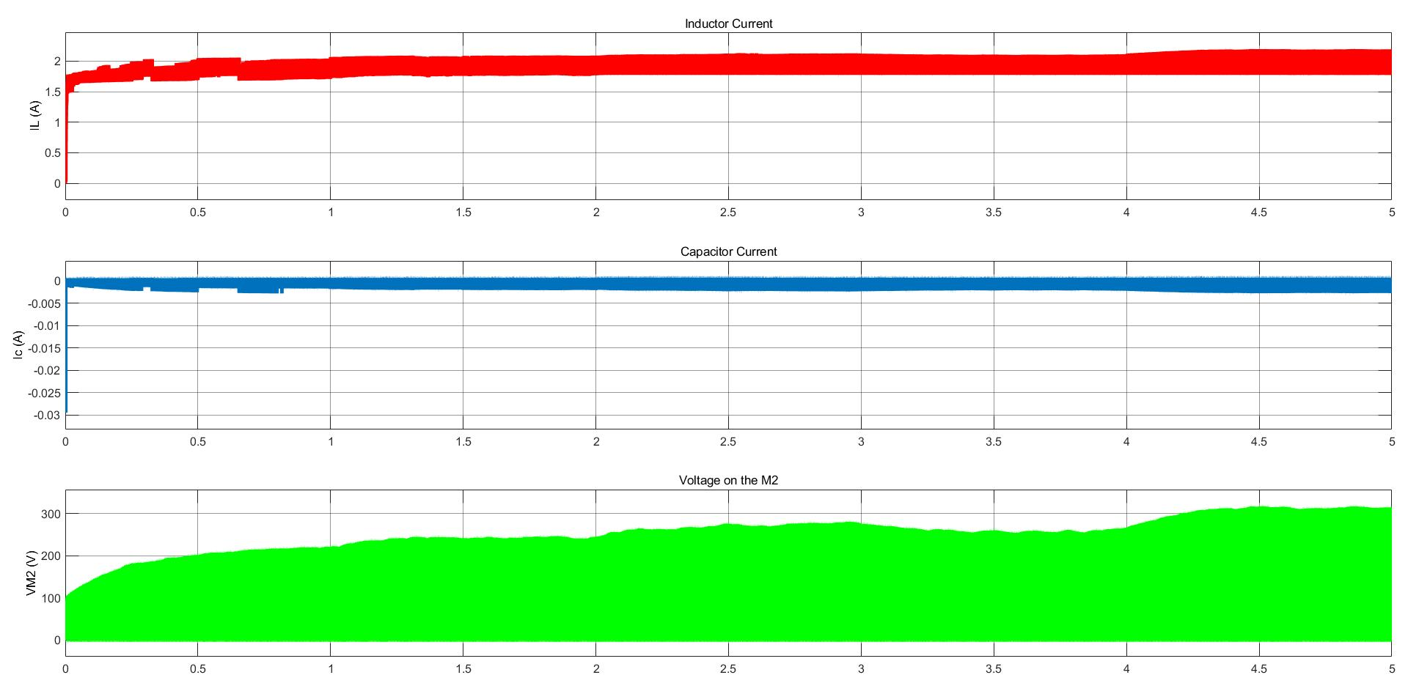

Figure 11. Converter components waveforms

As can be seen above figure inductor current reaches to approximately 2 amperes. Therefore, an inductor should be selected such that it can carry that much current over it. Accordingly, the PM2120-102K-RC inductor which is capable of carrying 2.5Amperes current should be selected. The size of the inductor was determined according to the output current ripples. For this scenario, 1mH inductor is enough to filter ripples up to the limited regions. The selected inductor is shown in figure 13.

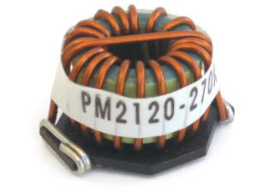

Figure 12. Buck converter PM2120-102K-RC inductance selection.

On the converter side switching elements need to be selected. For this application, mosfet as a switching element is selected due to its capability of carrying 300-350V applications and speed related advantages. As can be seen on figure 11, Mosfets are faced with 300-350V voltage over it. Therefore, FQD6N50C-D mosfet is selected, which can carry 1.5 multiples of the voltage stress over Mosfet for safety regarded issues. Its ratings can be seen in Table 3.

Table 3. Converter Side Mosfet Parameters

|  |  |
| --- | --- |
| **Component Code** | **FQD6N50C-D** |
|  | 500 V |
|  | 4.5A |
| Operating Temperature Range | -55℃ - 150℃ |
|  | 2.05 ℃/W |
|  | 110 ℃/W |
| Package | D-PAK FQD Series |

Last component that needs to be chosen based on figure 12 is the buck converter output capacitor. Since the battery is connected to the output, the capacitor is faced with 24V nominal battery voltage. The capacitor should be selected according to this criterion. Since this application does not require higher rated voltages tantalum capacitors will be enough for this type of application. The selected capacitor is 293D155X9050C2TE3‎. It has 1.5 microfarad capacitance, and is capable of 50V voltage. These properties are enough for this type of application.

Table 4. Buck Output Capacitor

|  |  |
| --- | --- |
| **Component Code** | **Rubycon MXH Series** |
| Rated Voltage Range | 50 |
| Size | 1.5 µF |
| Operating Temperature Range | -55℃ - 125℃ |
| Size of Capacitor | 7.3x4.3 mm |

* 1. **Battery Stage**

When the mosfet 1 is off, there will be no current that charges the capacitor. However, at that time the capacitor is charged from the battery. This will decrease the system efficiency. In order to prevent this action, a diode in the direction of the positive battery terminal can be placed. After inserting this diode, the battery will not feed the buck converter capacitor. Diode will prevent this action, and system efficiency also the battery charge oscillations is improved. For this operation the diode given in Table 4 is selected.

Table 5. Battery Input Diode Parameters

|  |  |
| --- | --- |
| **Component Code** |  |
|  | 3.0 A |
|  | 50 V |
|  | 150 ℃ |
|  | 0.90 V |
|  | SMC (DO-214AB) |

* 1. **Controller&Driver Selections**

The system is fed from the wind turbine generator torque. Therefore, its input voltage is not constant. It yields a requirement to use a controller in the output, so that system stabilize its output current in the desired range. For that purpose, TL594 PWM Control Circuit is selected.

* + 1. **Controller Parameters**

In order to implement TL594 controller component to the circuit, it is required to select the passive components that run the controller in the desired application form.

At that stage, from the data sheet typical application circuit is analyzed. Its components are rearranged such that it suits this project application. The selected components in this stage can be found in Table 5.

Table 6. TL594 Controller Passive Components

|  |  |  |
| --- | --- | --- |
| **Component** | **Component Name** | **Piece** |
| PWM Controller | TL594 | 1 |
| 1kΩ Resistance | RCA06031K00JNEA | 2 |
| 2.5 kΩ Resistance | RN732ATTD2501B25 | 1 |
| 23.5 kΩ Resistance | MCT06030C2352FP500 | 1 |
| 48 kΩ Resistance | CPF0805B48K7E | 1 |
| 5.1 kΩ Resistance | CRCW04025K10JNED | 2 |
| 9.1 kΩ Resistance | CRCW04029K10JNED | 1 |
| 51 kΩ Resistance | CRCW040251K0FKED | 1 |
| 510 Ω Resistance | CRCW0603510RJNEA | 1 |
| 4 kΩ Resistance | MCT06030C2352FP500 | 1 |
| Current Sense Resistance | RCWE0612 | 1 |
| 1 nF Capacitor | C1608JB2A102K080AA | 1 |
| 2.2 µF Capacitor | C1005X5R0J225K050BC | 1 |

In the selection of the passive components given in Table 5, the Figure 9 in Appendix is referred. There are several components that need to be changed according to this project requirement.

First of all, components are arranged for satisfying the oscillation frequency based on the below formulations.

In order to find the required , there exist 3 parameters with only 1 one of them is known, which is Thus, the strategy is taking 1 parameter suitable, then find the rest. The capacitor value is taken as in the datasheet example (1nF). Then, the rest is as follows.

Ω

In the circuit, there is current sense resistance, which has 1W power rating and has capability of current sense up to 10mV, in the load side. It takes output current, and it is compared with the pin 15 of the TL594. In pin 15, there is a voltage division with 2kΩ and 48kΩ resistances. They convert 5V reference voltage to 0.2V, and puts output current in 0.2A limit. That is the acceptable error in the output current waveform. From pin 1 and 2, there is another comparator. In there, in order to obtain 2.5V from the 26V output voltage there exists another voltage division. 2.5 kΩ and 26 kΩ resistances come from here. Circuit checks whether is there a larger than 2.5V voltage. If there exists, then it closes. If less it opens.

* + 1. **Driver Parameters**

In order to give the controlled signal to the system as a closed loop system, gate drivers are preferred. By arranging the duty cycle according to the load characteristics, the desired output waveforms can be obtained. For the NCP5181 gate driver, the possible application circuit can be found in Appendix Figure X.

For this design, it is required to select only 3 components; 2 Capacitor and 1 Diode. For capacitors, it is enough to choose small ceramic capacitors. There is not high voltage ratings over them. Therefore, selecting 0.2 µF 25V ceramic capacitor is enough for this operation. For the diode selection again as an optimum selection can be done. Thus, 60V 3A power diode is selected in order to satisfy the possible stresses in the circuit. Components are given in table 6.

Table 7. Gate Driver Components

|  |  |  |
| --- | --- | --- |
| **Component** | **Component Name** | **Piece** |
| Mosfet Gate Driver | NCP5181 | 1 |
| Power Diode | SBR3U60P5-7 | 1 |
| 0.2 µF Capacitor | 12063C204KAT4A | 2 |

1. **Thermal Analysis**

Converter mosfet >>>> 2 Piece

Rectifier Diode >>>> 1

Output diode >>>> 1

In the circuit, there are some components that creates heat. The heated components have some temperature limits, such that after that temperature components will damaged. Therefore, the overall circuit will be useless. In order to take into account this effect, the thermal analysis of the circuit is required.

In analysis part, there are 4 components that need to be considered in thermal view. These are rectifier diodes, converter MOSFETs and battery diode which disables charging the capacitor from the battery.

* 1. **Rectifier Diode Analysis**
  2. **Converter MOSFETs Analysis**

Over MOSFETs, there are 2 types of losses; switching losses and conduction losses. The calculations for these losses can be seen in below equations.

Switching losses are calculated by;

Conduction losses are calculated by;

1. **PCB Design**
2. **Cost Analysis**

In the cost analysis of the project, stage by stage analysis may simplify the understanding budget distribution. In the following Table 7, overall system cost analysis can be found stage by stage. These cost analysis are done by referring price per 1000 unit according to the project bonus specifications.

Table 8. Overall System Cost Analysis

|  |  |  |  |
| --- | --- | --- | --- |
| **Cost Analysis of the Project** | | | |
| **Component Code** | **Unit Price** | **Required Unit** | **Total Cost** |
| **Rectifier Stage** | | | |
| AS4PJ | $0.36 | 1 | $0.36 |
| Rubycon Mxh Series 270 µF | $3.37 | 2 | $6.74 |
| **Converter Stage** | | | |
| PM2120-102K-RC | $1.57 | 1 | $1.57 |
| FQD6N50C-D | $0.41688 | 2 | $0.83376 |
| ‎293D155X9050C2TE3‎ | $0.34291 | 1 | $0.34291 |
| **Battery Stage** | | | |
| ES3B | $0.14280 | 1 | $0.14280 |
| **Controller Components** | | | |
| TL594 | 0,326 € | 1 | 0,326 € |
| RCA06031K00JNEA | $0.011 | 2 | $0.022 |
| RN732ATTD2501B25 | $0.087 | 1 | $0.087 |
| MCT06030C2352FP500 | $0.01581 | 1 | $0.01581 |
| CPF0805B48K7E | $0.10578 | 1 | $0.21156 |
| CRCW04025K10JNED | $0.00511 | 2 | $0.01022 |
| CRCW04029K10JNED | $0.00511 | 1 | $0.00511 |
| CRCW040251K0FKED | $0.00596 | 1 | $0.00596 |
| CRCW0603510RJNEA | $0.00511 | 1 | $0.00511 |
| MCT06030C2352FP500 | $0.01581 | 1 | $0.01581 |
| RCWE0612 | $0.17350 | 1 | $0.17350 |
| C1608JB2A102K080AA | $0.0121 | 1 | $0.0121 |
| C1005X5R0J225K050BC | $0.4225 | 1 | $0.04225 |
| **Driver Components** | | | |
| NCP5181 | 0.829 € | 1 | 0.829 € |
| SBR3U60P5-7 | $0.24278 | 1 | $0.24278 |
| 12063C204KAT4A | $0.11453 | 2 | $0.22906 |
| **Total Cost** | | | $11.07 +1.155€ =  $12.46755 |

As can be understood from Table 8, overall system budget is $12.46755. Except 2 components, the rest is found in Digikey. The related bill of materials can be found in **Appendix B.** For the two components, which are controller and driver, they are ordered from Mouser. For this order, related chart is attached in **Appendix B** also.

1. **Conclusion**

In this report, the development process of an AC-DC battery charger is represented. First, the problem is defined and requirements are determined. Since the power supply is a wind turbine, frequency and amplitude of the generated electricity varies randomly. Therefore, the designed product should be capable of converting variable frequency and variable amplitude AC to constant current DC with determined specifications of the project. According to the problem definition and requirements, conceptual design is completed. Without diving into deep technical discussions, capabilities that product must have are determined. After the conceptual design stage, technical discussions are conducted and topology selection is made. In this stage, different topologies are compared and the best option is determined. Designed topology is simulated with ideal components and the operation conditions that the real components must be capable to work under are determined. According to the determined values, real components are found from the market. Then, the full simulation with real components is done and a PCB schematic is drawn. At the end of this report, the design process is completed.

After submitting this report, designed topology will be revised according to the feedback taken.

**References**

**Appendix A**

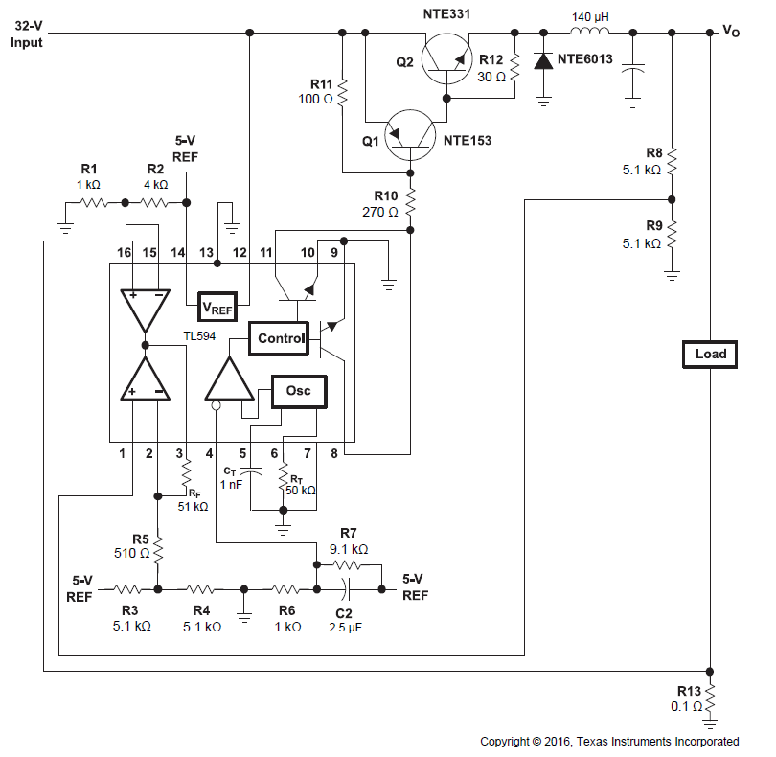

Figure 10.Typical TL594 Application Circuit

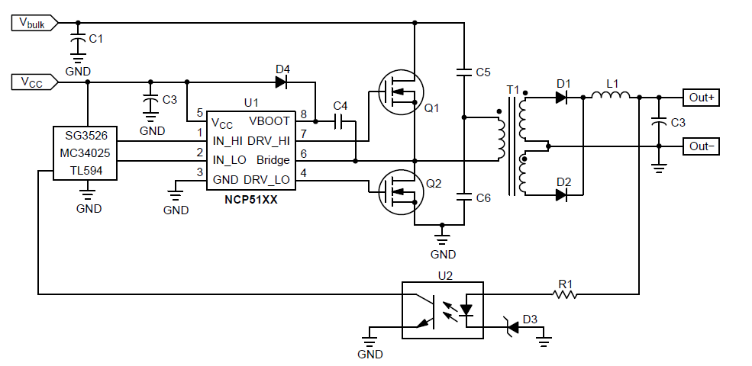

Figure 11.NCP5181 Typical Application Circuit

**Appendix B**

